**The National Business Portal of Jamaica**

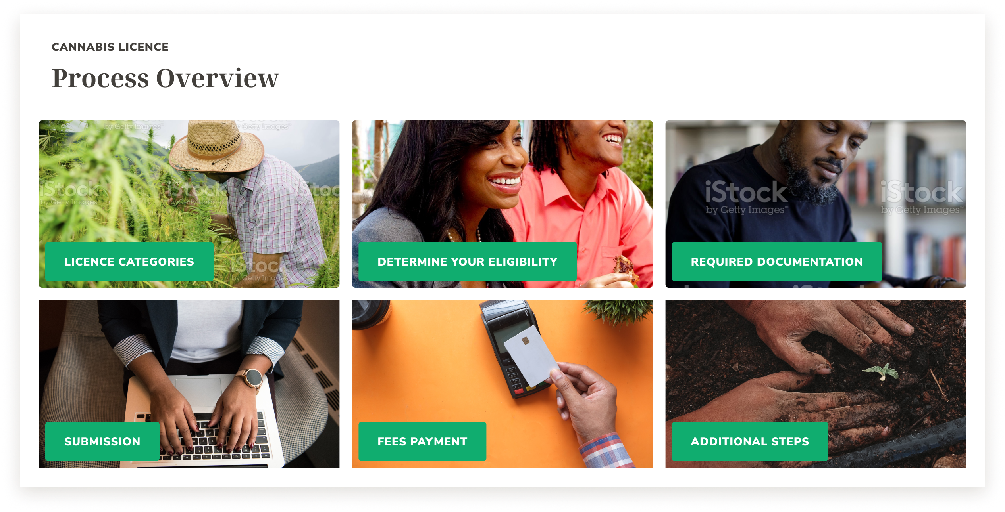**Design Specifications Report and**

**Assignment FCG/CON/078**

**DESIGN DEVELOPMENT AND IMPLEMENTATION OF THE NATIONAL BUSINESS PORTAL – NBP PHASE THREE**

**

**LPA CORPORATE SOLUTIONS (CARIBBEAN) LIMITED**

Presented to

Jamaica Promotions Corporation (JAMPRO Planning Institute of Jamaica (PIOJ)

23rd May 2022

# NBP Solution Design Report- Background

LPA CORPORATE SOLUTIONS (CARIBBEAN) LTD (The Consultant) was hired by the Planning Institute of Jamaica (PIOJ) to undertake the Design, Development, Implementation and Deployment of Phase Three of the National Business Portal (NBP). It is envisaged that the creation of the NBP will complement and support the implementation of a National Investment Policy (NIP), aimed at reforming the investment landscape of Jamaica, through the development of an online platform that will house the Business-to-Government online interface for all Government entities involved in the investment or business facilitation process.

The main objectives of the project are to design, develop and deploy a National Business Portal for the Government of Jamaica based on an intelligent and robust web content management system and digital experience platform as well as collect, analyze, format and upload all the data required to initially populate the Portal.

The Portal will be user friendly; and will act as a central repository for all regulatory information related to investment and business facilitation required by investors and businesses. It will aggregate and integrate all investment and business-related information, including that already available on individual Ministries’ and Agencies’ websites, in an easily accessible manner

The overall objective of the project is to strengthen the business environment in Jamaica for private sector investment by promoting broad-based private sector-led growth, improving the investment climate, modernizing infrastructure and logistics, as well as enhancing entrepreneurship and competitive industries.

It is envisaged that the creation of the National Business Portal (NBP) will complement and support implementation of the NIP through the development of an online platform that will house the Business-to-Government online interface for all Government entities involved in the investment or business facilitation process.

The Portal will be the central point through which all investments are routed, giving access to all relevant stakeholders, and thereby providing transparency and government cohesion.

# Introduction to the Design Report

**Objectives of the Report**

The Design report constitutes the architectural blue print of the system. It depicts in detail the:

* User Interface Designs
* System Prototypes
* Hardware Architectural Design
* Software Architectural Design
* Detailed Process Maps

The Design Report is Divided into the following documents/components

1. **Technical Architectural Report**
2. Hardware Architectural Design
3. Software Architectural Design
4. Hardware and Software Architectural Diagrams
5. Third Party Integration Design
6. Process Maps Designs of each Workflow Component of each Module
7. **User Interface Designs**
   1. Phase 1 Re-Design
   2. Phase 2 Design
   3. Style Book
8. **Video of UX Design**

**Scope of the Design Report (Phase 1 and Phase 3)**

The UX Designs for Phase 1 is focused on completely revamping the look and feel of the Portal. The Application for Cannabis Approval is used as the key prototypes for both Phase 1 and Phase 3 of the design elements. All pages from the Registration on the Portal to the selection of the menu items (phase1) to the flow of process instructions, have been redesigned with a graphically UX.

Key components of the Portal have also been depicted in the re-design of Phase1

**Phase 1 Re-Design**

* Distinct User Profiles
* Logged in Profile as opposed to a non-signed up profiles
* Investor User Profile
  + Discussion Board
  + Community Space
  + Instructional Process Flow
* Government User User
  + Discussion Board
  + Community Space
  + Reporting and Visualizations
* Business Facilitation Officer Profile
  + Discussion Board

**Phase 3 Design- Cannabis Application Process- used as the Prototype**

* Submission of Application Process
* Due Diligence Dashboard
* Discussion Board
  + Notifications
  + Collaborations
* Conditional/License Dashboard
  + Renewals
  + Expiring Documents
* Inspection/Calendaring Dashboard
* Process Tracker with Transaction History
* License Issuance Dashboard
* Community
  + News
  + Articles

**Index of Deliverables – UX and Prototype Designs**

|  |  |  |
| --- | --- | --- |
| **Deliverable Filename** | **Section** | **Position** |
| Presentation | Introduction | Page 3 |
| Deliverables | Page 8 |
| Static Prototypes Overview | Page 12–65 |
| — Homepage | Page 13 |
| — News and Articles | Page 17 |
| — Community and discussion boards | Page 20 |
| — Secure Cannabis License | Page 25 |
| — Cannabis License (Application Process) | Page 36 |
| — Investor Dashboard | Page 50 |
| — Government User | Page 57 |
| — Business Facilitators User Boards | Page 64 |
| Stylebook and Dev References | Palette and Colours | Page 3–6 |
| Typography | Page 7–12 |
| Imagery | Page 13 |
| Iconography | Page 14 |
| Interaction | Page 15–20 |
| Back-office Colour Scheme | Page 21 |
| Prototypes | **Phase-1** |  |
| Homepage (Investor) | https://www.figma.com/file/ld1Ib9HqDGlWCg7k0juQ2y/?node-id=49%3A10 |
| Homepage (Visitor) | https://www.figma.com/file/ld1Ib9HqDGlWCg7k0juQ2y/?node-id=503%3A59072 |
| Service Page «Secure Approvals» | https://www.figma.com/file/ld1Ib9HqDGlWCg7k0juQ2y/?node-id=317%3A1741 |
| Sub-service Page «Cannabis Licence» | https://www.figma.com/file/ld1Ib9HqDGlWCg7k0juQ2y/?node-id=695%3A79920 |
| — (Superseded legacy textual version) | https://www.figma.com/file/ld1Ib9HqDGlWCg7k0juQ2y/?node-id=301%3A601 |
| Community Overview | https://www.figma.com/file/ld1Ib9HqDGlWCg7k0juQ2y/?node-id=317%3A3241 |
| — Discussions | https://www.figma.com/file/ld1Ib9HqDGlWCg7k0juQ2y/?node-id=439%3A39842 |
| — — Threads and Categories | https://www.figma.com/file/ld1Ib9HqDGlWCg7k0juQ2y/?node-id=439%3A41214 |
| — — Discussion Messages | https://www.figma.com/file/ld1Ib9HqDGlWCg7k0juQ2y/?node-id=375%3A36490 |
| — News & Articles | https://www.figma.com/file/ld1Ib9HqDGlWCg7k0juQ2y/?node-id=395%3A29949 |
| — Article Detail | https://www.figma.com/file/ld1Ib9HqDGlWCg7k0juQ2y/?node-id=395%3A32635 |
| **Phase-3** |  |
| **«Cannabis Licence» Application Form** | |
| — Step 1 — Application Type | https://www.figma.com/file/ld1Ib9HqDGlWCg7k0juQ2y/?node-id=332%3A15638 |
| — Step 2 — Licence Category | https://www.figma.com/file/ld1Ib9HqDGlWCg7k0juQ2y/?node-id=332%3A17333 |
| — Step 3 — Application Details | https://www.figma.com/file/ld1Ib9HqDGlWCg7k0juQ2y/?node-id=337%3A15195 |
| — Step 4 — Supporting Documents | https://www.figma.com/file/ld1Ib9HqDGlWCg7k0juQ2y/?node-id=337%3A17321 |
| — Step 5 — Payment | https://www.figma.com/file/ld1Ib9HqDGlWCg7k0juQ2y/?node-id=337%3A18616 |
| — Step 6 — Confirmation page | https://www.figma.com/file/ld1Ib9HqDGlWCg7k0juQ2y/?node-id=547%3A70032 |
| Private Investor Dashboard |  |
| — Overview | https://www.figma.com/file/ld1Ib9HqDGlWCg7k0juQ2y/?node-id=463%3A44689 |
| — Licence Application Case Detail (Overview) | https://www.figma.com/file/ld1Ib9HqDGlWCg7k0juQ2y/?node-id=476%3A57621 |
| — Collaboration drill-down | https://www.figma.com/file/ld1Ib9HqDGlWCg7k0juQ2y/?node-id=809%3A113082 |
| Government Portal (Homepage) | https://www.figma.com/file/ld1Ib9HqDGlWCg7k0juQ2y/?node-id=387%3A29969 |
| Interactive Prototypes | Homepage (Visitor) | https://www.figma.com/proto/ld1Ib9HqDGlWCg7k0juQ2y/Jamaica-NBP-Prototypes?node-id=169%3A104&viewport=-50%2C88%2C0.11&scaling=min-zoom&starting-point-node-id=503%3A59072&show-proto-sidebar=1 |
| Homepage (Investor) | https://www.figma.com/proto/ld1Ib9HqDGlWCg7k0juQ2y/Jamaica-NBP-Prototypes?node-id=169%3A104&viewport=-50%2C88%2C0.11&scaling=min-zoom&starting-point-node-id=476%3A81017&show-proto-sidebar=1 |
| Cannabis License | https://www.figma.com/proto/ld1Ib9HqDGlWCg7k0juQ2y/Jamaica-NBP-Prototypes?node-id=169%3A104&viewport=-50%2C88%2C0.11&scaling=min-zoom&starting-point-node-id=317%3A1741&show-proto-sidebar=1 |
| Cannabis Licence Application Form | https://www.figma.com/proto/ld1Ib9HqDGlWCg7k0juQ2y/Jamaica-NBP-Prototypes?node-id=169%3A104&viewport=-12616%2C8%2C0.47&scaling=min-zoom&starting-point-node-id=332%3A15638&show-proto-sidebar=1 |
| Private Investor’s Dashboard | https://www.figma.com/proto/ld1Ib9HqDGlWCg7k0juQ2y/Jamaica-NBP-Prototypes?node-id=169%3A104&viewport=-12616%2C8%2C0.47&scaling=min-zoom&starting-point-node-id=463%3A44689&show-proto-sidebar=1 |
| Government Portal | https://www.figma.com/proto/ld1Ib9HqDGlWCg7k0juQ2y/Jamaica-NBP-Prototypes?node-id=169%3A104&viewport=-9791%2C183%2C0.37&scaling=min-zoom&starting-point-node-id=387%3A29969&show-proto-sidebar=1 |